**NIM : 3311911002**

**Nama : Linargian Pratama**

**Kelas : IF 2 A karyawan**

**PHP MYSQL**

**(koneksi, tampil data, tambah data, ubah data, hapus data)**

# 1. Buat database dan tabel

Buatlah database dan tabel dari PHPMyadmin (localhost/phpmyadmin) dengan struktur database sebagai berikut:

* Nama Database : db_akademik
* Nama Tabel : mahasiswa
* Struktur tabel : nim Char(10)

nama Varchar(30) alamat Varchar(30) jurusan Varchar(30)

* Isi data mahasiswa sebanyak 2 baris data

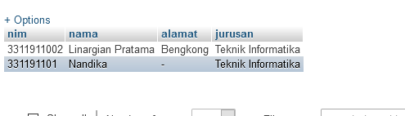

2. Download folder admin yang tersedia dilearning kemudian extract kedalam folder xampp→htdocs

- Jalankan di browser url: **localhost/admin** - Tuliskan hasinya dibawah ini :

|  |
| --- |
|  |

# 3. Koneksi

* Buat file baru ketikkan kode berikut simpan di dalam folder admin yang sudah di download dengan nama koneksi.php

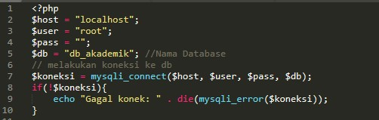

* Buka file **index.php** pada folder **admin**
* Tambahkan kode berikut dibawah teks **“TAMBAH DATA MAHASISWA </a>”**

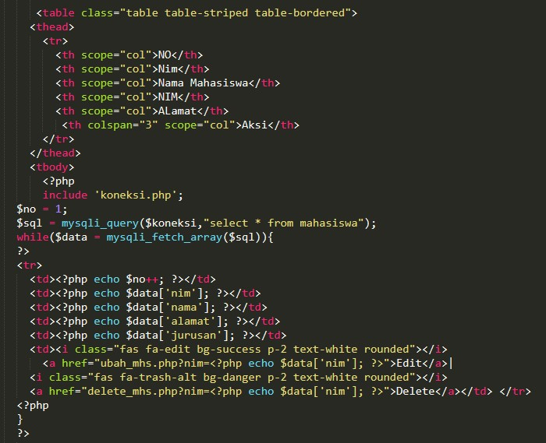

* Jalankan di web browser tuliskan hasilnya dibawah ini

|  |
| --- |
|  |

# 4. Tambah Data

- Buka file baru ketikkan (**copy**) kode berikut simpan dengan nama **tambah_mhs.php**

|  |
| --- |
| <!doctype html>  <html lang="en">  <head>  <!-- Required meta tags -->  <meta charset="utf-8">  <meta name="viewport" content="width=device-width, initial-scale=1, shrink-to-fit=no">    <!-- Bootstrap CSS -->  <link rel="stylesheet" href="css/bootstrap.min.css" >  <link rel="stylesheet" type="text/css" href="admin.css">  <link rel="stylesheet" type="text/css" href="fontawesome/css/all.min.css"> <title>ADMINISTRATOR</title>  </head> <body>  <nav class="navbar navbar-expand-lg navbar-light bg-warning fixed-top">  <a class="navbar-brand" href="#">SELAMAT DATANG ADMIN</a>  <button class="navbar-toggler" type="button" data-toggle="collapse" data-  target="#navbarSupportedContent" aria-controls="navbarSupportedContent" aria-expanded="false" aria-label="Toggle navigation">  <span class="navbar-toggler-icon"></span>  </button>  <div class="collapse navbar-collapse" id="navbarSupportedContent">  <form class="form-inline my-2 my-lg-0 ml-auto">  <input class="form-control mr-sm-2" type="search" placeholder="Search" aria-label="Search"> <button class="btn btn-outline-success my-2 my-sm-0" type="submit">Search</button>  </form>  <div class="icon ml-4">  <h5>  <i class="fas fa-envelope-square mr-3"></i>  <i class="fas fa-bell-slash mr-3"></i>  <i class="fas fa-sign-out-alt mr-3"></i>  </h5>  </div>  </div>  </nav>  <div class="row no-gutters mt-5">  <div class="col-md-2 bg-dark mt-2 pr-3 pt-4">  <ul class="nav flex-column ml-3 mb-5">  <li class="nav-item">  <a class="nav-link active text-white" href=""><i class="fas fa-tachometer-alt mr-  2"></i>Dashboard</a><hr class="bg-secondary">  </li>  <li class="nav-item">  <a class="nav-link text-white" href=""><i class="fas fa-user-graduate mr-2"></i>Daftar Mahasiswa</a><hr class="bg-secondary"> |

|  |
| --- |
| </li>  <li class="nav-item">  <a class="nav-link text-white" href="" ><i class="fas fa-users mr-2"></i>Daftar Pegawai</a><hr    class="bg-secondary">  </li>  <li class="nav-item">  <a class="nav-link text-white" href="" ><i class="far fa-calendar-alt mr-2"></i>Jadwal Kuliah</a><hr class="bg-secondary">  </li>  </ul>  </div>    <div class="col-md-10 p-5 pt-2">  <h3><i class="fas fa-user-graduate mr-2"></i> Input Data Baru</h3><hr>  **<form action="simpan_mhs.php" method="post">**    <div class="form-row">  <div class="form-group col-md-4">  <label >NIM</label>  <input type="text" name="nim" class="form-control" id="nim">  </div>  </div>  <div class="form-row">  <div class="form-group col-md-6">  <label >NAMA</label>  <input type="text" name="nama" class="form-control" id="nama">  </div>  </div>    <div class="form-row">  <div class="form-group col-md-6">  <label >ALAMAT</label>  <input type="text" name="alamat" class="form-control" id="alamat"> </div>  </div>  <div class="form-row">  <div class="form-group col-md-6">  <label >JURUSAN</label>  <input type="text" name="jurusan" class="form-control" id="jurusan"> </div>  </div>  <button type="submit" class="btn btn-primary">SIMPAN</button> </form>  </div>  </div>  </body>  </html> |

1. Buat file baru ketikkan kode berikut simpan dengan nama **simpan_mhs.php**

|  |
| --- |
| <?php  include 'koneksi.php'; $nim = $_POST['nim'];  $nama = $_POST['nama'];  $alamat= $_POST['alamat'];  $jurusan = $_POST['jurusan'];  $input = mysqli_query($koneksi,"INSERT INTO mahasiswa  VALUES('$nim','$nama','$alamat','$jurusan')") or die(mysql_error()); if($input){  echo "Data Berhasil Disimpan";  header("location:index.php");  }else{  echo "Gagal Disimpan";  }  ?> |

1. Jalankan di web browser “Klik tombol kemudian isi **data mahasiswa dan simpan**.
2. Tuliskan hasilnya dibawah ini:

|  |
| --- |
|  |

1. Ubah Data
   * Buat file baru ketikkan kode berikut simpan dengan nama file **ubah_mhs.php**

|  |
| --- |
| <?php  include 'koneksi.php'; $nim = $_GET['nim'];  $result = mysqli_query($koneksi, "SELECT * FROM mahasiswa WHERE nim='$nim'"); while($user_data = mysqli_fetch_array($result))  {  $nama = $user_data['nama'];  $alamat = $user_data['alamat'];  $jurusan = $user_data['jurusan'];  }    ?>  <!doctype html>  <html lang="en">  <head>  <!-- Required meta tags -->  <meta charset="utf-8">  <meta name="viewport" content="width=device-width, initial-scale=1, shrink-to-fit=no">    <!-- Bootstrap CSS -->  <link rel="stylesheet" href="css/bootstrap.min.css" >  <link rel="stylesheet" type="text/css" href="admin.css">  <link rel="stylesheet" type="text/css" href="fontawesome/css/all.min.css"> <title>ADMINISTRATOR</title>  </head> <body>  <nav class="navbar navbar-expand-lg navbar-light bg-warning fixed-top">  <a class="navbar-brand" href="#">SELAMAT DATANG ADMIN</a>  <button class="navbar-toggler" type="button" data-toggle="collapse" data-  target="#navbarSupportedContent" aria-controls="navbarSupportedContent" aria-expanded="false" arialabel="Toggle navigation">  <span class="navbar-toggler-icon"></span>  </button>  <div class="collapse navbar-collapse" id="navbarSupportedContent">  <form class="form-inline my-2 my-lg-0 ml-auto">  <input class="form-control mr-sm-2" type="search" placeholder="Search" aria-label="Search"> <button class="btn btn-outline-success my-2 my-sm-0" type="submit">Search</button>  </form>  <div class="icon ml-4">  <h5>  <i class="fas fa-envelope-square mr-3"></i>  <i class="fas fa-bell-slash mr-3"></i>  <i class="fas fa-sign-out-alt mr-3"></i>  </h5>  </div>  </div> |

|  |
| --- |
| </nav>  <div class="row no-gutters mt-5">  <div class="col-md-2 bg-dark mt-2 pr-3 pt-4">  <ul class="nav flex-column ml-3 mb-5">  <li class="nav-item">  <a class="nav-link active text-white" href=""><i class="fas fa-tachometer-alt mr-  2"></i>Dashboard</a><hr class="bg-secondary">  </li>  <li class="nav-item">  <a class="nav-link text-white" href=""><i class="fas fa-user-graduate mr-2"></i>Daftar Mahasiswa</a><hr class="bg-secondary">  </li>  <li class="nav-item">  <a class="nav-link text-white" href=""><i class="fas fa-chalkboard-teacher mr-2"></i>Daftar  Dosen</a><hr class="bg-secondary">  </li>  <li class="nav-item">    <a class="nav-link text-white" href="" ><i class="fas fa-users mr-2"></i>Daftar Pegawai</a><hr class="bg-secondary">  </li>  <li class="nav-item">  <a class="nav-link text-white" href="" ><i class="far fa-calendar-alt mr-2"></i>Jadwal Kuliah</a><hr class="bg-secondary">  </li> </ul>  </div>  <div class="col-md-10 p-5 pt-2">  <h3><i class="fas fa-user-graduate mr-2"></i> Ubah Data Mahasiswa</h3><hr>  **<form action="update_mhs.php" method="post">**    <div class="form-row">  <div class="form-group col-md-4"> <label >NIM</label>  <input type="text" name="nim" class="form-control" id="nim" value=<?php echo $nim;?>>  </div>  </div>  <div class="form-row">  <div class="form-group col-md-8"> <label >NAMA</label>  <input type="text" name="nama" class="form-control" id="nama" value=<?php echo $nama;?>>  </div>  </div>    <div class="form-row">  <div class="form-group col-md-6"> <label >ALAMAT</label>  <input type="text" name="alamat" class="form-control" id="alamat" value=<?php echo $alamat;?>>  </div>    </div> |

|  |
| --- |
| <div class="form-row">  <div class="form-group col-md-6">  <label >JURUSAN</label>  <input type="text" name="jurusan" class="form-control" id="jurusan" value=<?php echo $jurusan;?>>  </div>  </div>  <button type="submit" class="btn btn-primary">SIMPAN</button>  </form>  </div>  </div>    </body>  </html> |

* + Buat file baru ketikkan kode berikut simpan dengan nama file **update_mhs.php**

|  |
| --- |
| <?php  // include database connection file include 'koneksi.php';    $nim= $_POST['nim'];  $nama=$_POST['nama'];  $alamat=$_POST['alamat'];    $jurusan=$_POST['jurusan'];  $result = mysqli_query($koneksi, "UPDATE mahasiswa SET nama='$nama',alamat='$alamat',jurusan='$jurusan' WHERE nim='$nim'");  // Redirect to homepage to display updated user in list header("Location: index.php"); ?> |

* + Jalankan file index.php klik tombol 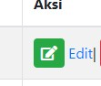 pada salah satu record, kemudian ubah data dam simpan.

* + Tuliskan hasilnya dibawah ini

|  |
| --- |
|  |

1. Hapus Data
   * Buat file baru ketikkan kode berikut simpan dengan nama file **hapus_mhs.php**

|  |
| --- |
| <?php  // include database connection file include 'koneksi.php'; $nim = $_GET['nim'];  $result = mysqli_query($koneksi, "DELETE FROM mahasiswa WHERE nim='$nim'"); header("Location:mahasiswa.php"); ?> |

* + Jalankan file index.php klik tombol 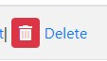 pada salah satu bari record.

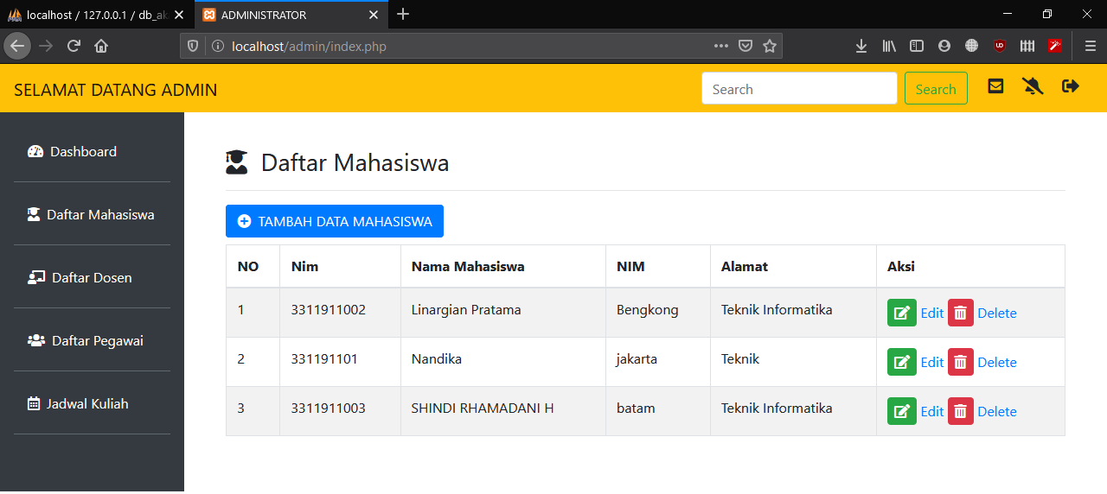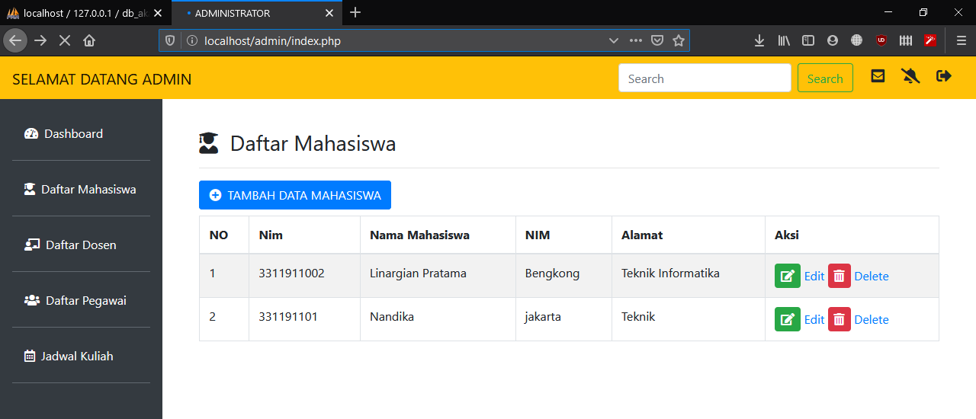

# TUGAS

Buatlah program tambah, ubah, update, hapus data untuk data dosen, pegawai dan jadwal kuliah dengan struktur tabel sebagai berikut:

1. Tabel dosen:
   * nidn char (10)
   * nama Varchar(30)
   * alamat Varchar(30)
   * jabatan Varchar(10)
2. Tabel Pegawai:
   * nik char(10)
   * nama Varchar(30)
   * bagian Varchar(20)
3. Tabel jadwal kuliah disesuaikan dengan jadwal kuliah masing yang ada di Politeknik Batam.